- SAP HANA Smart Data Access allows you to access remote data through virtualization, as if the data was stored in local tables in SAP HANA, without copying the data into SAP HANA.
- This provides operational and cost benefits along with the ability to access, synthesize and integrate data from multiple systems in real-time.
- In SAP HANA, you create virtual tables, which point to remote tables in different data sources and then write SQL queries in SAP HANA, using these virtual tables.
- The SAP HANA query processor optimizes these queries by executing the relevant part of the query in the target database, returning the results of the query to SAP HANA, and then completing the operation.
- Physical data movement is not supported by SAP HANA Smart Data Access.
​
Supported sources on Intel-based hardware platforms:
- SAP HANA
- SAP IQ
- SAP Adaptive Server Enterprise
- SAP Event Stream Processor
- SAP HANA Streaming Analytics
- SAP MaxDB
- Apache Hadoop
- Teradata Database
- Microsoft SQL Server 2012
- Oracle Database 12C
- IBM DB2
- IBM Netezza Appliance
- Apache Spark
- SAP HANA Smart Data Integration provide tools to access source data and provision, replicate, and transform that data in SAP HANA on-premise or in the cloud.
- SAP HANA Smart Data Integration lets you enhance, cleanse, and transform data to make it more accurate and useful.
- You can efficiently connect to any source to provision and cleanse data for loading into SAP HANA on-premise or in the cloud, and for supported systems, writing back to the original source.
- SAP Smart Data integration currently supports 28 Adapter types to cater to different sources of data.
- Provides built-in adapters plus an SDK so you can build your own adapters. Includes the following features and tools:
  - Replication Editor
  - Transformations
  - Data Provisioning Agent
  - Data Provisioning adapters
  - An Adapter SDK
  - Monitors
- Data Provisioning Server
- The Data Provisioning Server is a native SAP HANA process.
- It's built as an index server variant, runs in the SAP HANA cluster, and is managed and monitored just like other SAP HANA services.
- It provides native connectivity for many sources and connectivity to the Data Provisioning Agent.
- The Data Provisioning Server is installed with, but must be enabled in, the SAP HANA server.
- Data Provisioning Agent
- The Data Provisioning Agent is a container running outside the SAP HANA environment, and it's managed by the Data Provisioning Server.
- The agent provides connectivity for all those sources where the driver can't run inside the Data Provisioning Server.
- Through the agent, the preinstalled Data Provisioning Adapters communicate with the Data Provisioning Server for connectivity, metadata browsing, and data access.
- The agent also hosts custom adapters created using the Adapter SDK.
- The Data Provisioning Agent is installed separately from SAP HANA server or client.
- Replication Editor
- And
- Flowgraph Editor
- The Replication Editor allows you to set up replication tasks that replicate data from several objects in a remote source to tables in SAP HANA.
- The Flowgraph Editor provides an interface to create data provisioning and data quality transformation flowgraphs.
Replication/Flowgraph editor functionality is delivered in the following tools:
- SAP Business Application Studio
- SAP Web IDE
- SAP Web IDE for SAP HANA
- SAP HANA Web-based Development Workbench
The tools available depend on your deployment scenario.

HANA_IM_DP delivery unit
Note : This component is relevant only for SAP HANA on-premise and the SAP HANA Service for SAP BTP in the Neo environment
- This bundles monitoring and administration capabilities. It also includes the Data Provisioning Proxy for connecting to the SAP HANA Service for SAP BTP in the Neo environment.
Delivery unit includes the following functionality:
- Data Provisioning administration application
- Data Provisioning Proxy
- Data Provisioning
SAP ABAP
ABAPAdapter
- Retrieves data from virtual tables through RFC for ABAP tables and ODP extractors.
- It also provides change data capture for ODP extractors.
SAP ASE LTL
ASELTLAdapter
- Retrieves data from SAP ASE.
- It can also receive changes that occur to tables in real time.
- You can also write back to a virtual table.
- This adapter uses Log Transferring Language (LTL) technology exclusively.
SAP ECC
- ASELTLECCAdapter
- DB2ECCAdapter
- MssqlECCAdapter
- OracleECCAdapter
- Retrieves data from an SAP ERP system running on a supported database.
- The only difference between these adapters and each corresponding log reader or LTL adapter is that these adapters use the data dictionary in the SAP ERP system when browsing metadata.
SAP HANA
HanaAdapter
- Provides real-time changed-data capture capability in order to replicate data from a remote SAP HANA database to a target SAP HANA database.
- You can also write back to a virtual table.
- Use this adapter to extract data from an ECC on an SAP HANA source.
- Microsoft Excel
- ExcelAdapter
- Retrieves data from a Microsoft Excel file or SharePoint source data.
- Microsoft Outlook
- OutlookAdapter
- OutlookAdapter
- Microsoft SQL Server Log Reader
- MssqlLogReaderAdapter
- Retrieves data from Microsoft SQL Server. It can also receive changes that occur to tables in real time through log reading or triggers. You can also write back to a virtual table.
- Agent Management
- AgentMgmtAdapter
- Allows SAP HANA to access and execute Data Provisioning Agent functions
- Apache Camel Facebook
- CamelFacebookAdapter
- Connects to and retrieves data from Facebook.
- This adapter is a predelivered component that is based on the Apache Camel adapter
- Apache Camel Informix
- CamelInformixAdapter
- Retrieves data from an Informix source. It can also write back to an Informix virtual table.
- This adapter is a predelivered component that is based on the Apache Camel adapter
- Apache Camel JDBC
- CamelJDBCAdapter
- Connects to most databases for which SAP HANA smart data integration doesn’t already provide a predelivered adapter.
- In general, the Camel JDBC adapter supports any database that has SQL-based data types and functions, and a JDBC driver.
- This adapter is a predelivered component that is based on the Apache Camel adapter.
- Apache Camel Microsoft Access
- CamelAccessAdapter
- Retrieves data from a Microsoft Access source.
- This adapter is a predelivered component that is based on the Apache Camel adapter.
- Apache Cassandra
- CassandraAdapter
- Retrieves data from an Apache Cassandra remote source.
- This adapter is a predelivered component that is based on the Apache Camel adapter.
- Apache Impala
- ImpalaAdapter
- Retrieves data from an Apache Impala source.
- This adapter is a predelivered component that is based on the Apache Camel adapter.
- Cloud Data Integration
- CloudDataIntegrationAdapter
- Retrieves data from a Cloud Data Integration (CDI) service endpoint.
- Data Assurance
- DataAssuranceAdapter
Connects to an SAP HANA remote source to use the Data Assurance option to monitor the quality of data replication
File
FileAdapter
- Retrieves data from formatted text files or SharePoint source data. You can also write back to a virtual table or an HDFS target file.
- File Datastore Adapters
- FileAdapterDatastore
- SFTPAdapterDatastore
- Reads from a wide variety of sources by using the SAP Data Services engine as the underlying technology.
- Hive
- HiveAdapter
- Retrieves data from Apache Hadoop via Apache Hive.
- IBM DB2 Log Reader
- DB2LogReaderAdapter
- Retrieves data from IBM DB2. It can also receive changes that occur to tables in real time. You can also write back to a virtual table.
- OData
- ODataAdapter
- Retrieves data from an OData service. You can also write to an OData target.
- Oracle Log Reader
- OracleLogReaderAdapter
- Retrieves data from Oracle. It can also receive changes that occur to tables in real time through log reading or triggers. You can also write back to a virtual table.
- PostgreSQL Log Reader
- PostgreSQLLogReaderAdapter
Batch-loads or replicates change data in real time from a PostgreSQL database to SAP HANA
SDI DB2 LTL Mainframe
DB2LTLMainframeAdapter
- Provides real-time replication functionality for IBM DB2 on z/OS sources. This adapter uses Log Transferring Language (LTL) technology exclusively.
Note: This adapter doesn't come preinstalled with the Data Provisioning Agent; you must install it separately after you install the agent.
- SOAP
- SoapAdapter
- Connects to a web service using the HTTP protocol to download data. This adapter is a SOAP web services client and uses virtual functions instead of virtual tables to expose server-side operations as it closely relates to how the operation is invoked.
- Teradata
- TeradataAdapter
- Retrieves data from Teradata. It can also receive changes that occur to tables in real time. You can also write back to a virtual table
- Twitter
- TwitterAdapter
- Retrieves data from Twitter. It can also receive new data from Twitter in real time.

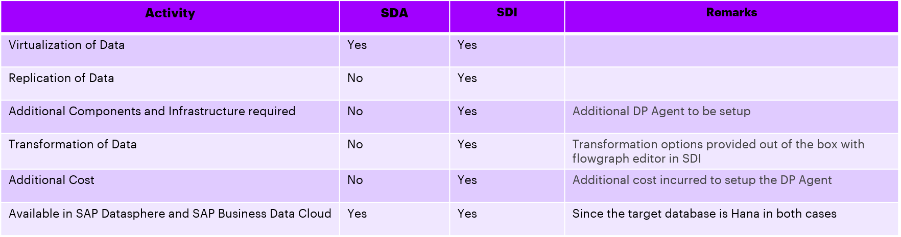
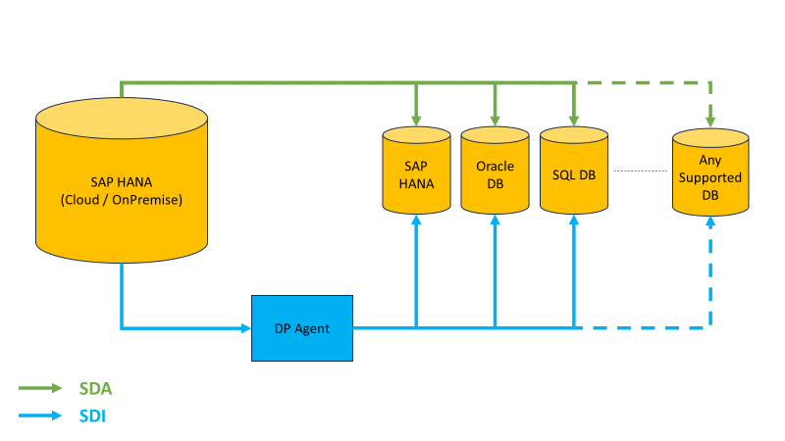

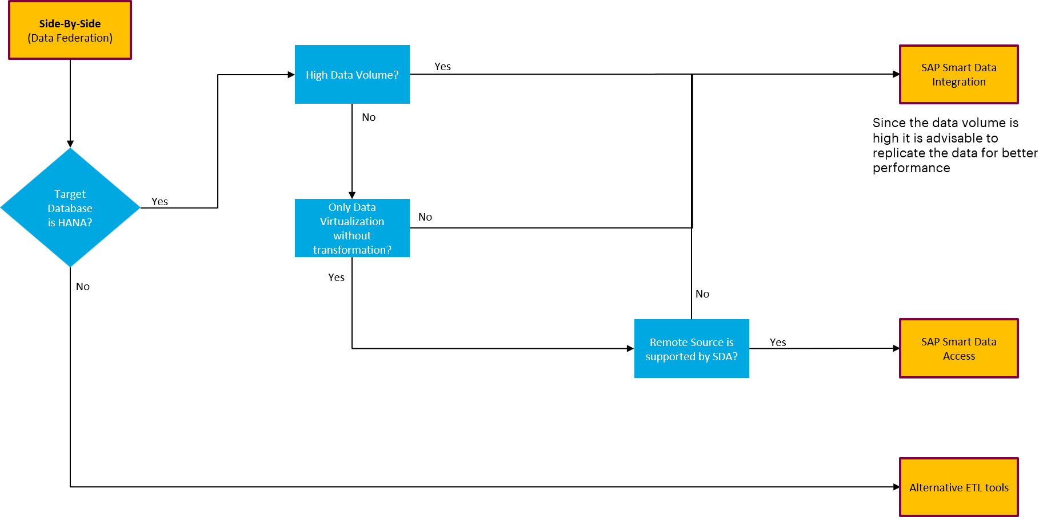

Smart Data Access
- Create a report using tables on various remote database tables without storing the data on SAP HANA.
- All the data is virtualized and hence the report will show accurate Realtime data without any additional cost.
- Can be used in SAP Datasphere and SAP Business Data Cloud where real-time access to data is required.

Smart Data Integration
- Create a report on huge volume of data from various sources which requires complex transformations.
- Data can be transformed and replicated to HANA Cloud.
- In case data replication or complex transformations are required SDI needs to be used.
- Can be used in SAP Datasphere and SAP Business Data Cloud to establish real-time replication of data with complex transformations.
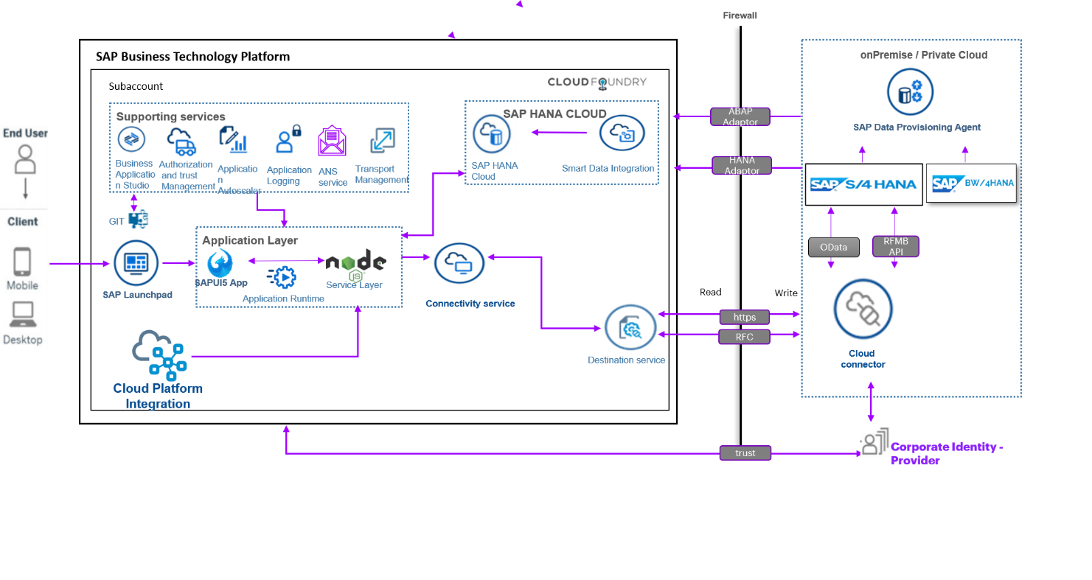
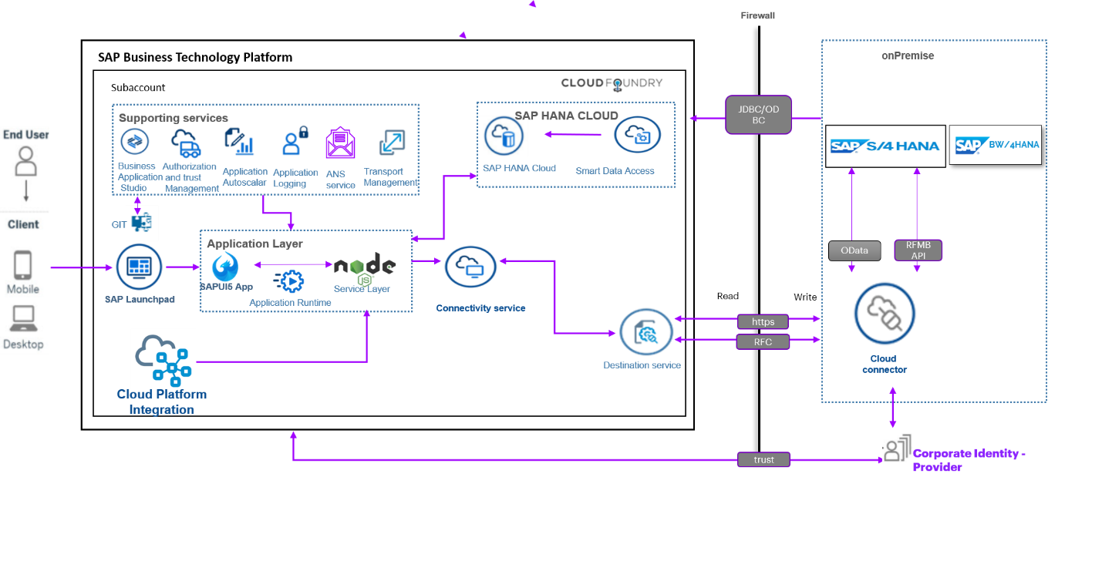

Smart Data Access
- Because smart data access is part of the SAP HANA, no additional licensing is required to use it. Additional support packages and patches are available for download from the SAP Software Download Center and are installed using the SAP HANA database lifecycle manager (HDBLCM).
- For a list of supported remote source databases and versions, see SAP Note 2600176 - SAP HANA Smart Data Access Supported Remote Sources.
Smart Data Integration
- If you have HANA Enterprise license, SDI license is included.
- If you have HANA Std Edition license, the HANA “Information Management Option” (IMO) license is needed to use SDI.
- "HANA platform edition" is not licensed with SDI.
- SDI requires installation of a DP Agent and a DP Server in addition to the SAP HANA Database or service in the cloud. It is a complete ETL Solution which can cater to all requirements in a project. The infrastructure required to host the DP Agent will be additional cost incurred.
- Functionality provided by SDA is a subset of SDI. If the requirement is just to virtualize data on demand and the remote data source is supported by SDA then SDA can be used without any additional installations to be done.
- If the requirement is to read, replicate or transform data from various sources for which adapter is available in the DP Agent then SDI can be considered as an option.
- SDI is an extension of the functionalities provided by SDA and can cover almost all the scenarios required in a landscape.
- For More information and SAP documentation please refer below links:
- SAP HANA Smart Data Integration and SAP HANA Smart Data Quality | SAP Help Portal
- SAP HANA Smart Data Access | SAP Help Portal

